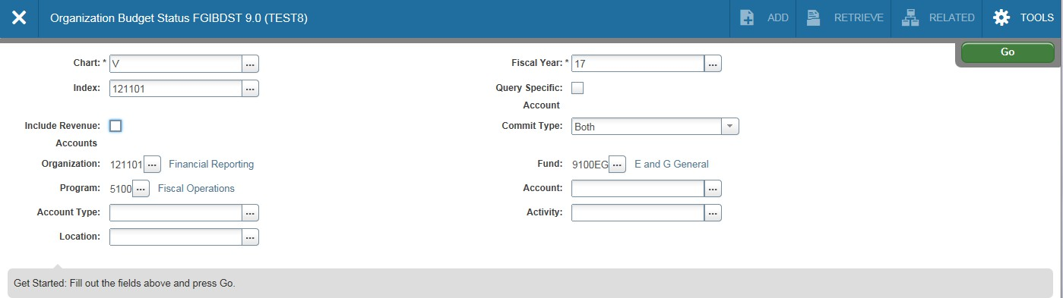FGIBDST-Organization Budget Status
(acronym=Finance, General Ledger, Inquiry, Budget Status)
This page is probably one of the most useful pages in Banner. It provides up to date information on adjusted
budgets, year-to-date expenditures, open commitments and available balances. In the key block area, select
your fiscal year (if other than current) and type in your Index code. Press the tab key on your keyboard. If you
want to view all financial data for this index, leave the Account field blank. If this particular index does not earn
revenues, remember to uncheck Include Revenue Accounts or your Net Totals will be returned as negative
values. Leave the Commit Type Indicator set to Both. VCU does not use this feature. Click on the “Go” icon to
see the results.

Enter Index code

Uncheck Include Revenue Accounts if Leave Commit Type as Both. VCU
Index does not earn revenues. does not use this feature.

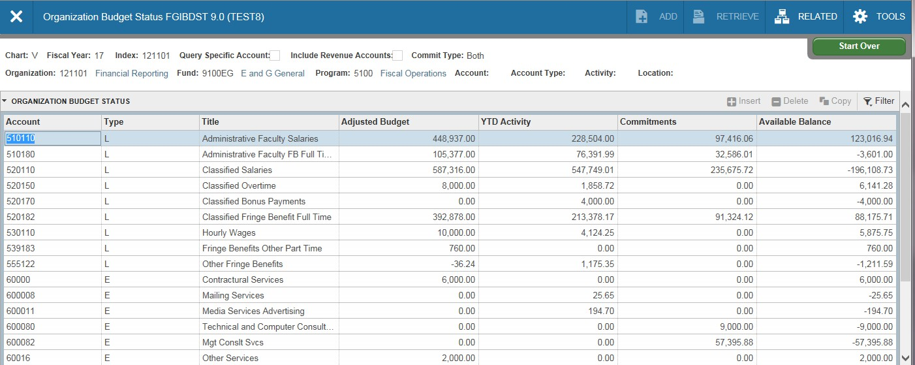FGIBDST (continued)-You’ll need to use the scroll bar to view all the accounts returned on this
page. The Adjusted Budget shown is your Current Budget. YTD Activity is year-to-date expenditures
through today. Commitments are your encumbrances (outstanding purchase orders, etc.). The Available Balance field includes your commitments (deducts from your balance).

Use the Scroll Bar to move
through the page.

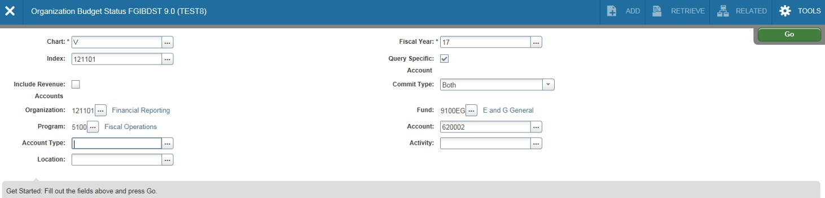FGIBDST(continued)-To view detailed transactions that make up your year-to-date activity, you can
enter the Account you wish to view in the account field; be sure the “Query Specific Account” box is
selected; then select the “GO” icon; highlight the specific account from the account list. This will give
you a list of all transactions (budget, expenses and commitments) that posted to that account code.

Check the Query Specific Account
box

Enter account.

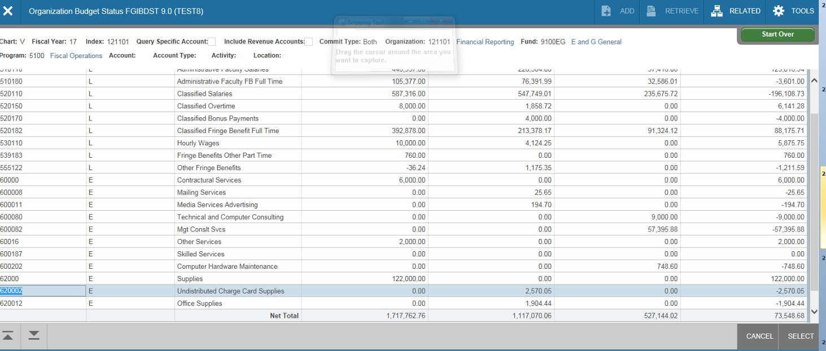FGIBDST(continued) click once in the field for the transactions you want to view (for the specific
account you wish to investigate). In this case, year to date activity for Undistributed Charge Card
Supplies. Then, press the F3 key on your keyboard. This brings up page FGITRND.

Click into the box you wish to see
a more detail listing of activity, hit
F3

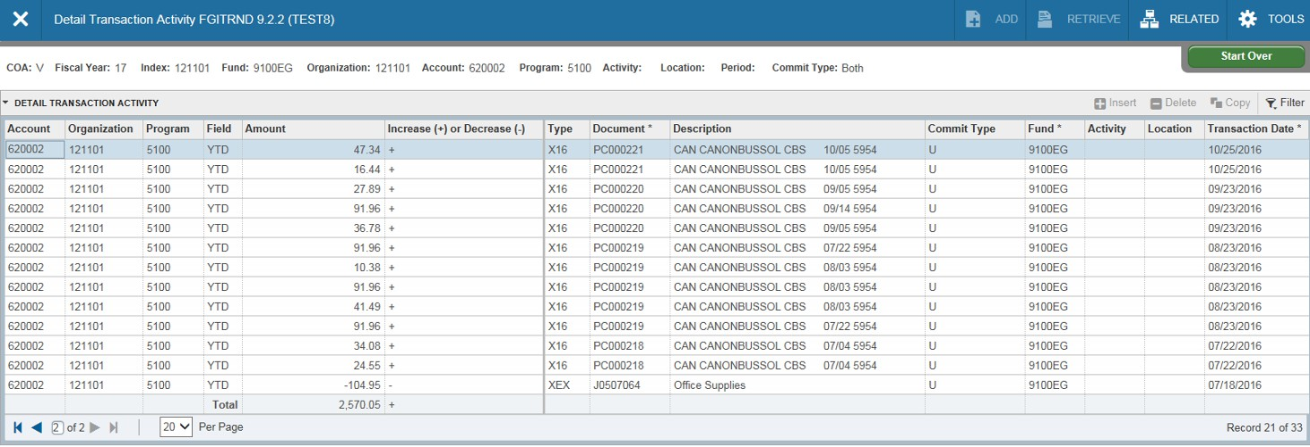Page FGITRND (Transaction Detail) will open showing all transactions that have posted to the account.
Transactions with YTD in the Field column are items that have been paid. ENC in the field column are
commitments (purchase orders). Transactions with fields beginning with AB or OB are budget related
entries.
The Type column (the Banner rule class) identifies the specific type of transaction. Transactions beginning
with X are journal voucher entries. The X type entries shown here are corporate card purchases which are
uploaded as a journal voucher each month. Types beginning with H are wage related entries. Payments to
vendors are types beginning with I. Creation of a purchase order is identified with type beginning with P.

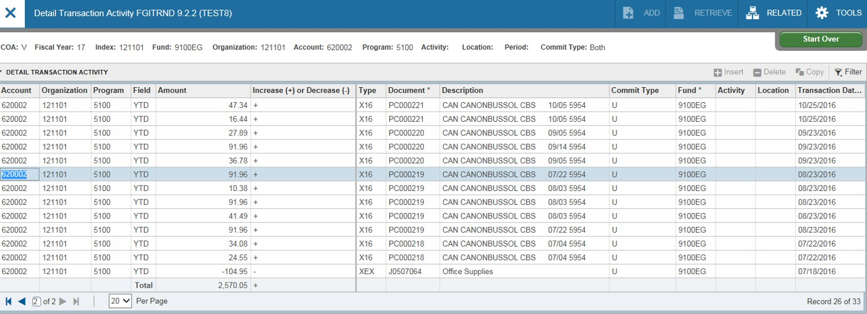FGITRND (continued)-To view more detailed information about a transaction, click once on the line of the transaction you wish to query. Select F3. Ensure the document and document type are correct (remember “X” represents a journal voucher type).

Click once to highlight the line, select F3.

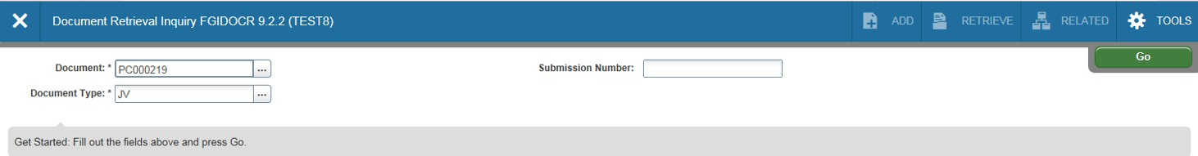FGIDOCR (Document Retrieval) will open. At first, this form will appear blank. In order to view details of the selected transaction, ensure the document and document type are correct (remember “JV”
represents a journal voucher document) and select “Go” icon.

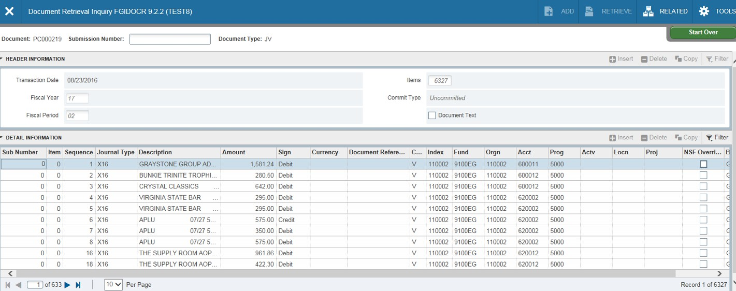FGIDOCR (continued) - Details of the transaction will display. To find the specific line item, you will need to scroll through the items or add a “filter”.

Select Filter, where you will have multiple choices to filter on a specific piece of information.

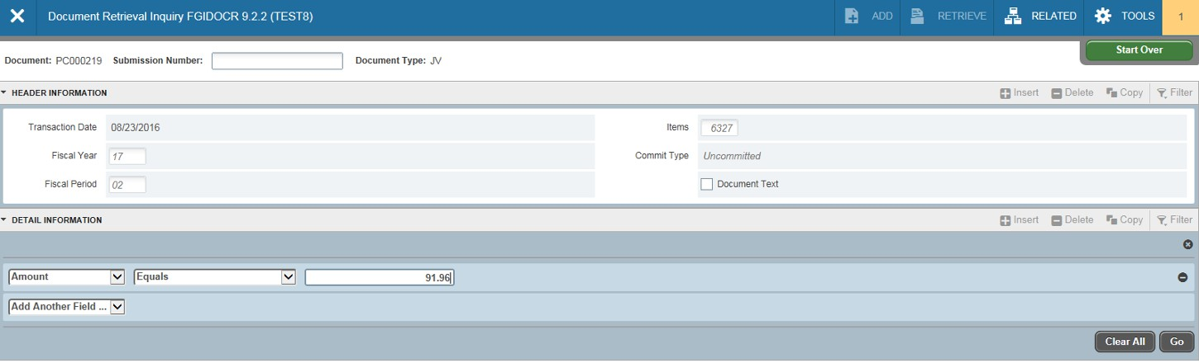FGIDOCR (continued) - We have elected to use the amount. Enter the applicable amount, and select “Go” icon

Select Filter, where you will have multiple choices to filter on a specific piece of information. Select “Go”.

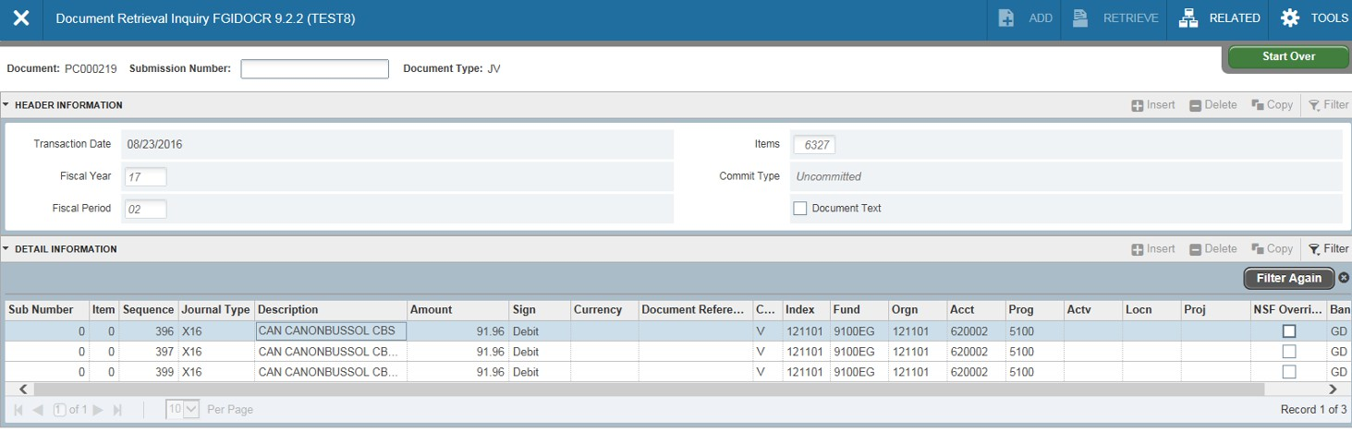FGIDOCR (continued)-Details of the transaction will display. To obtain more information, select the line, and hit F3. To return to FGITRND (Transaction Detail) or the FGIBDST (Budget Status) page, simply click the black X on the Banner menu bar until you return to your starting point.

Exit until you return back to your Select the line item, and hit F3 for more information
starting point.

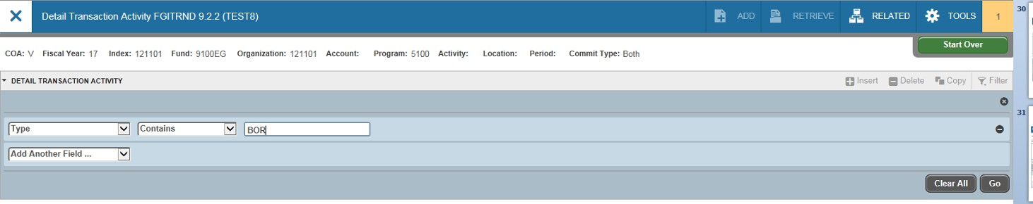FGITRND-You can also use this page for queries. After entering the Index information and selecting “GO”.
Click on the Next Block icon. A block will appear asking to add another field will appear under “Detail
Transaction Activity”. Enter your query parameters. In this example, we’re looking for all original permanent
budget entries for this organization. The original permanent budget is loaded at the beginning of the fiscal year.
In the Field column, enter OBD. Next click on the “Go” icon.

Select “Type”, enter BOR

Select “Go”

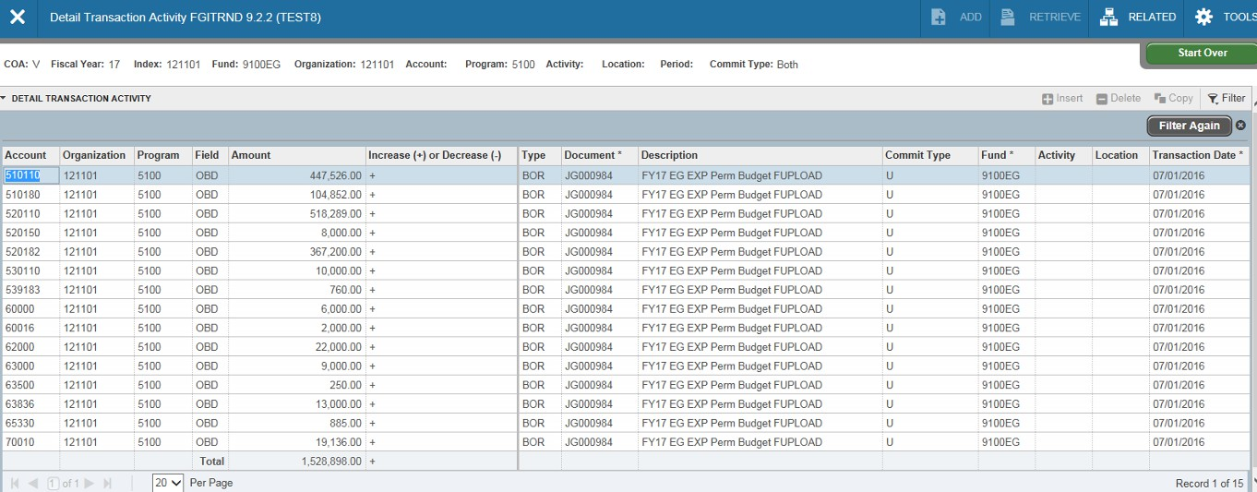FGITRND (continued)-All original permanent budget entries that were posted to this
organization will be returned on the page. You can use more than one parameter on this page to
confine your search to more specific information. You’ll find other examples in the pages Handbook located in the Course Documents section of this course.

Banner Transaction Query Forms

▪ FGIJVCD - List of Suspended Journal Vouchers
▪ Not posted yet (Pending Status)
▪ Can query by document number or get a complete list

▪ FGITRND - Detail Transaction Activity
▪ Shows the transactions posted to the Org ▪ Query by rule class

▪ FGIDOCR - Document Retrieval Inquiry
▪ Shows Posted transaction detail
▪ Must know document number

