Viewing Banner Finance Documents in Banner 9 Self-Service
Controller’s Office

- You can view Banner Finance documents in Banner 9 Self-Service.
- Log into Banner 9 Self-Service through “myVCU” found on the VCU homepage. https://www.vcu.edu/
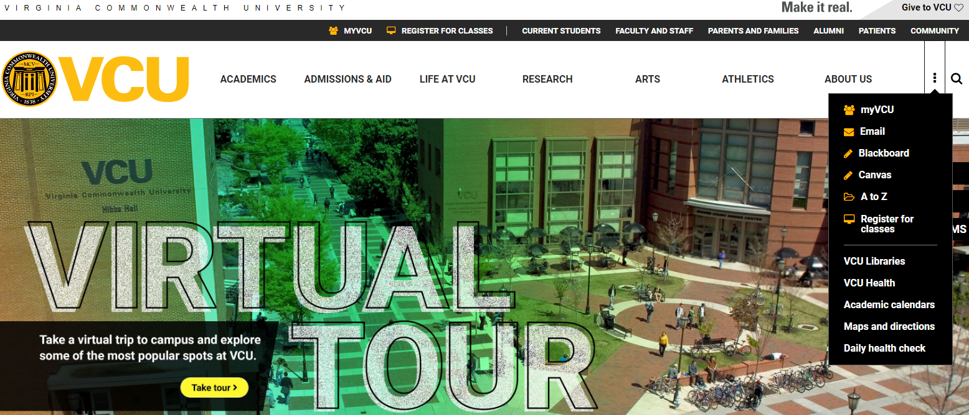

- Click on “eServices/VCU Self Service”.
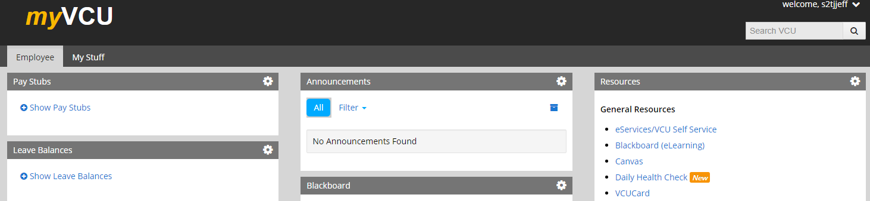

- Navigate to the Finance page using the menu at the top.
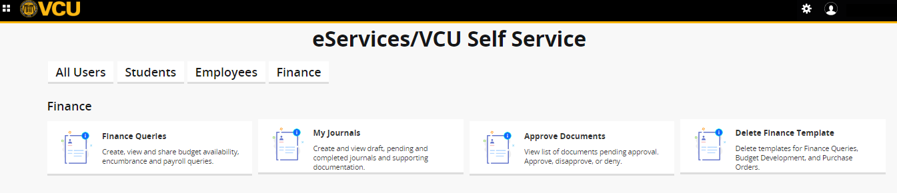
- Click on “Finance Queries”.

- Click on the “magnifying glass”.
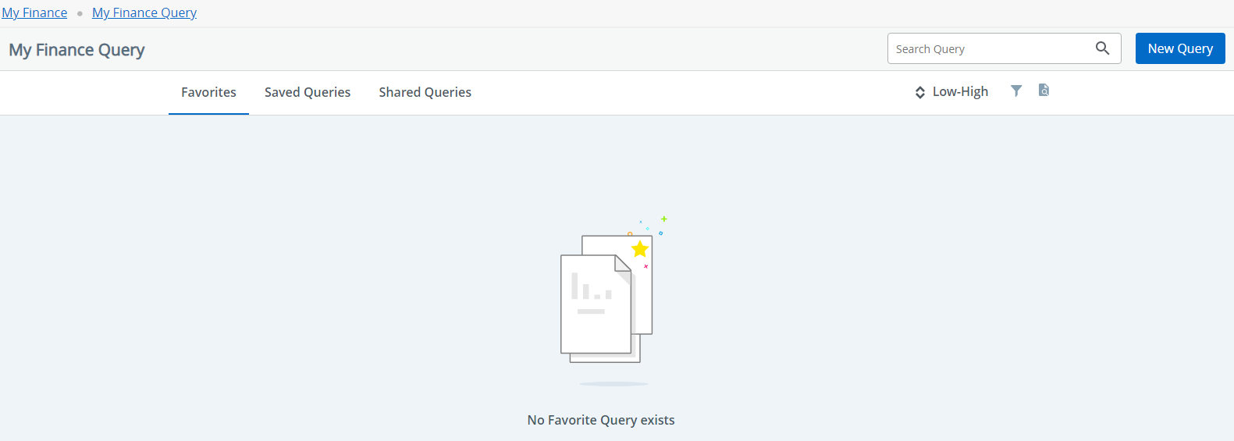

- Select the appropriate “document type”, such as “journal voucher”.
- Tip: Options for “requisition” and “direct cash receipt” are not used at VCU.
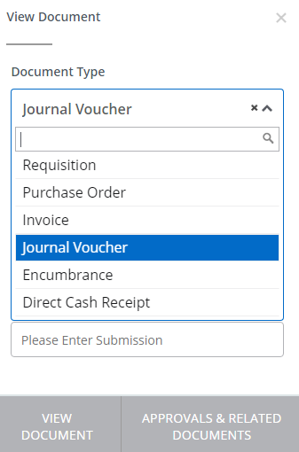

- Use the “document search” field to look up a document number. Or, type the document number directly into the “document number” field. The asterisk means an entry in the field is required.
- The “submission” field can be left blank.
- Click on “approvals & related documents” to view user approver details.
- Click on “view document” to open the PDF.
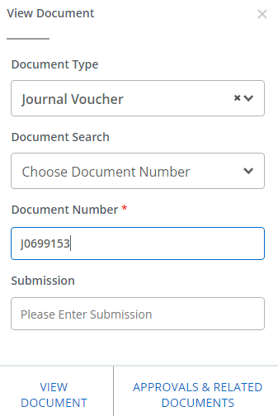

- The “view document” results will display accounting information about the journal voucher.
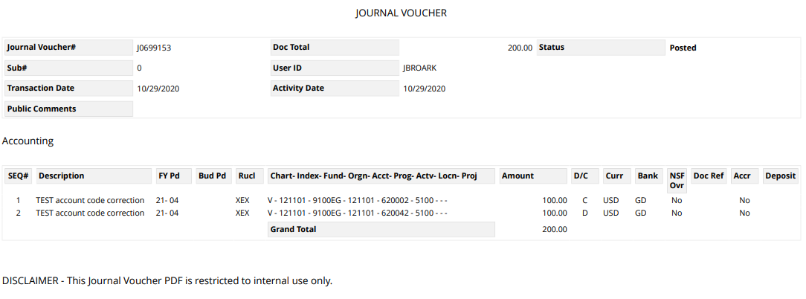
- To view another document (such as an invoice, an encumbrance, or a purchase order), close the PDF to return to the “view document” window and repeat the similar steps above.

