Removing a Travel Encumbrance
in Self-Service

Controller’s Office

Removing a Travel Encumbrance in Self-Service
There are instances where a travel encumbrance needs to be removed manually. For instance, if a travel pre-approval was not attached to the expense report, the encumbrance will not liquidate automatically. First, you will need to find out some specific information about the encumbrance you want to remove. Go to Banner form FGIENCD and enter the travel encumbrance document number (begins with Txxxxxxx). Click on Go.
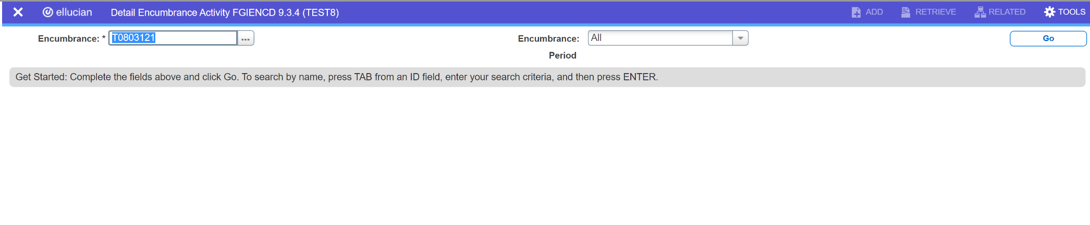

Alternative to FGIENCD: The information found on FGIENCD can also be found in the VCU Reporting Center, Finance Folder, Report entitled “Open Encumbrances.” This report can be run by MBU, Department, Subdepartment, and Organization code.

Removing a Travel Encumbrance in Self-Service
From FGIENCD, note the item number, sequence number, index, and account. You will need this information to enter the encumbrance removal in Self-Service.
This must be done for each line of the encumbrance, if there are multiple items/sequence numbers. To get this information, check the bottom of the “Encumbrance Detail” section, and hit the right arrow button to view the next record(s).
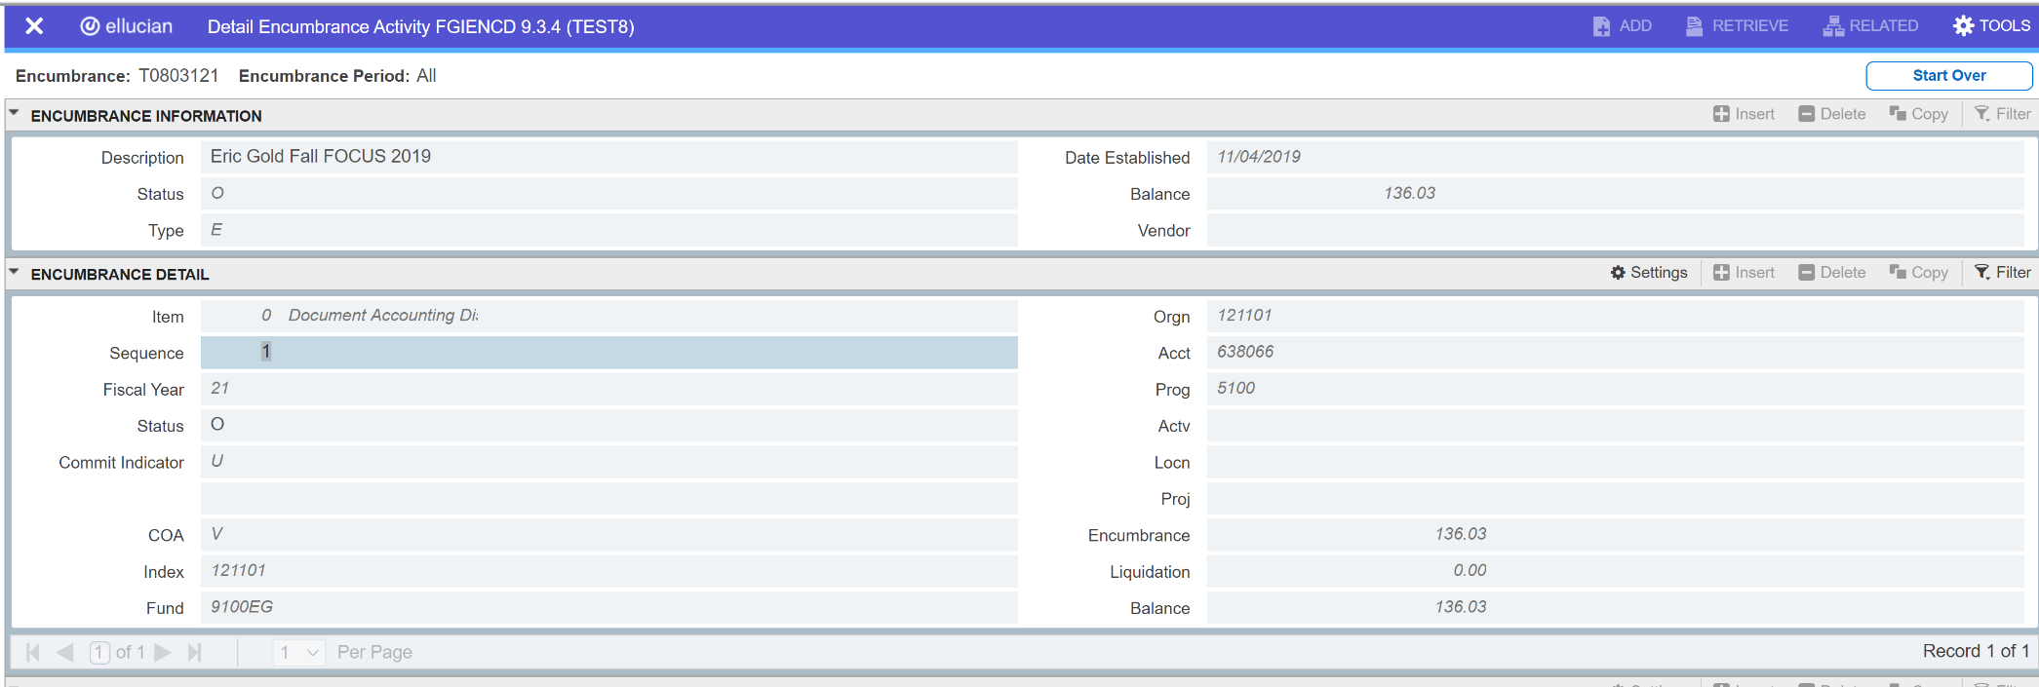

Removing a Travel Encumbrance in Self-Service
After logging into VCU Self-Service, navigate to the Finance Landing Page. From the Finance Landing Page, click on My Journals.
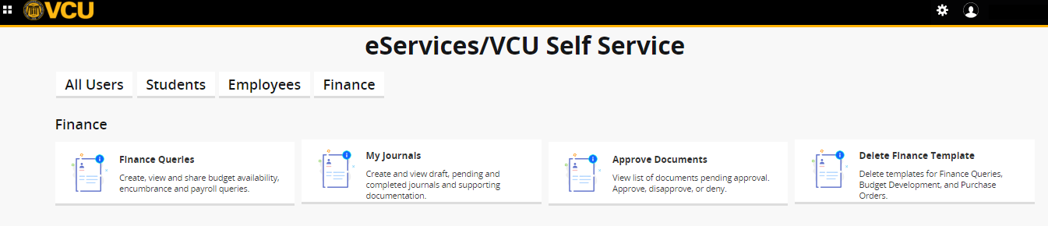

Removing a Travel Encumbrance in Self-Service
From the My Journals page, click on Create Journal. The Create Journal screen will open.

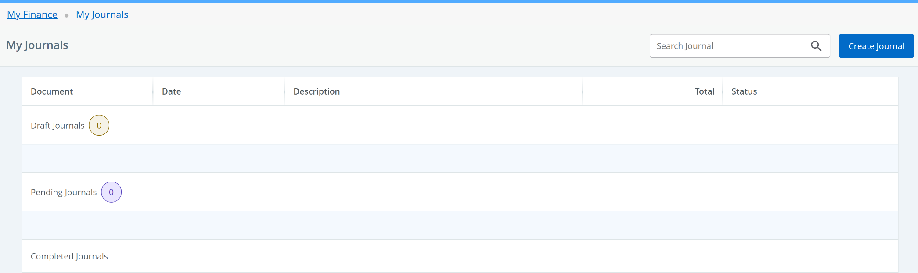

Removing a Travel Encumbrance in Self-Service
On the Create Journal screen, enter the following data:
Transaction Date: will auto-populate to today’s date
Distribution Total: 0.00 (total should always be zero for travel encumbrance removals)
Journal Type: E032
Description: enter description
Bank Code: DB
After entering the data, click CREATE.
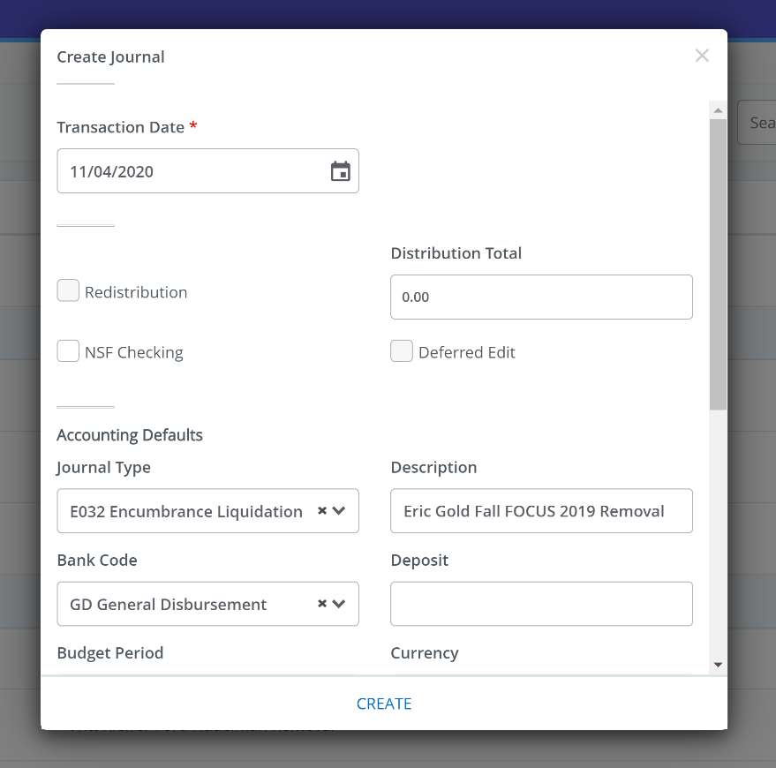
DB BoA Disbursement

Removing a Travel Encumbrance in Self-Service
After clicking CREATE, the Add Accounting screen will open. Use the information noted from Banner FGIENCD to enter the accounting information.
Journal Type: E032
Chart: V
Index: enter Travel Encumbrance index (fund and org will self-populate)
Account: enter Travel Encumbrance account code
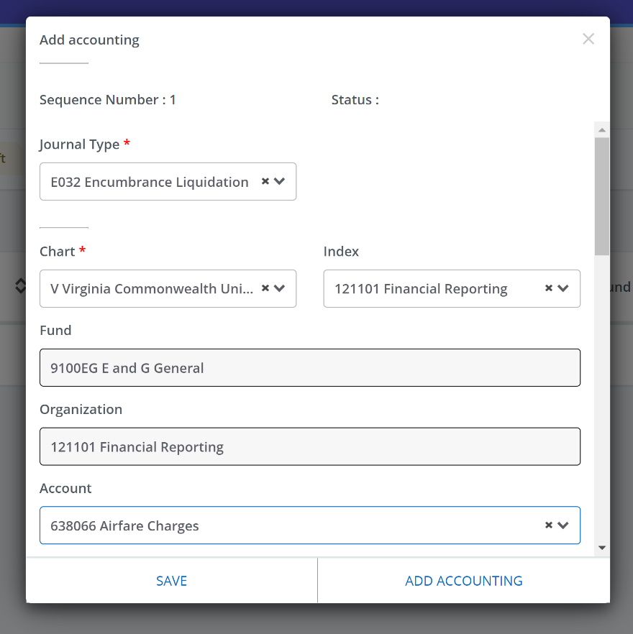

Removing a Travel Encumbrance in Self-Service
Scroll down on the Add Accounting screen to continue entering the following accounting information.
Amount: 0.00 (total should always be zero for travel encumbrance removals)
Debit/Credit: + Plus
Description: enter description
Bank Code: DB

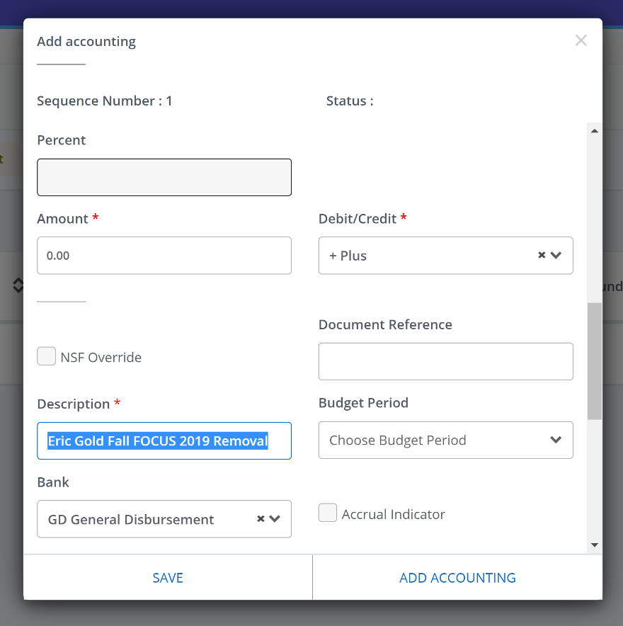
DB BoA Disbursement

Removing a Travel Encumbrance in Self-Service
Scroll down on the Add Accounting screen to continue entering the following accounting information.
Encumbrance Number: enter Travel Encumbrance number
Item Number: enter Travel Encumbrance item number
Sequence: enter Travel Encumbrance sequence number
Once you are finished entering the accounting information, click SAVE. Or if you need to add another line, such as for additional encumbrances or items/sequences for the same encumbrance, click ADD ACCOUNTING and complete the steps to enter the accounting information for the next line.
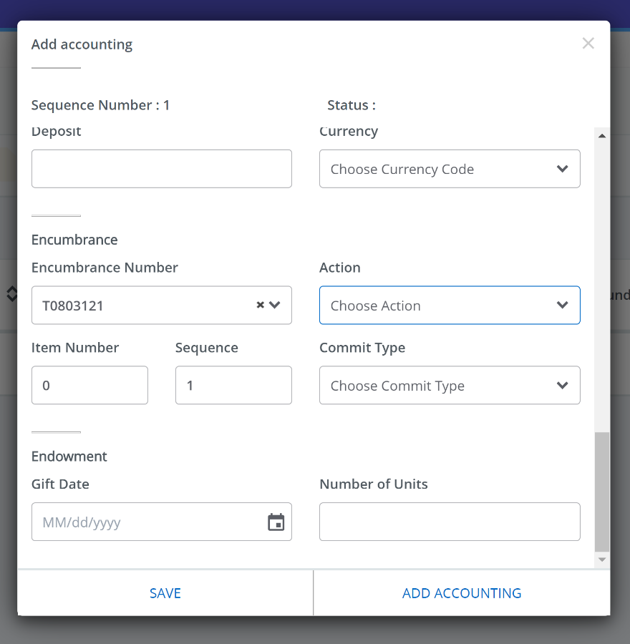
OR

Removing a Travel Encumbrance in Self-Service
After clicking SAVE on the Add Accounting screen, the journal voucher draft will be displayed. The assigned document number will be listed in the top left of the screen. After reviewing the draft, click Submit Journal to submit the journal voucher.
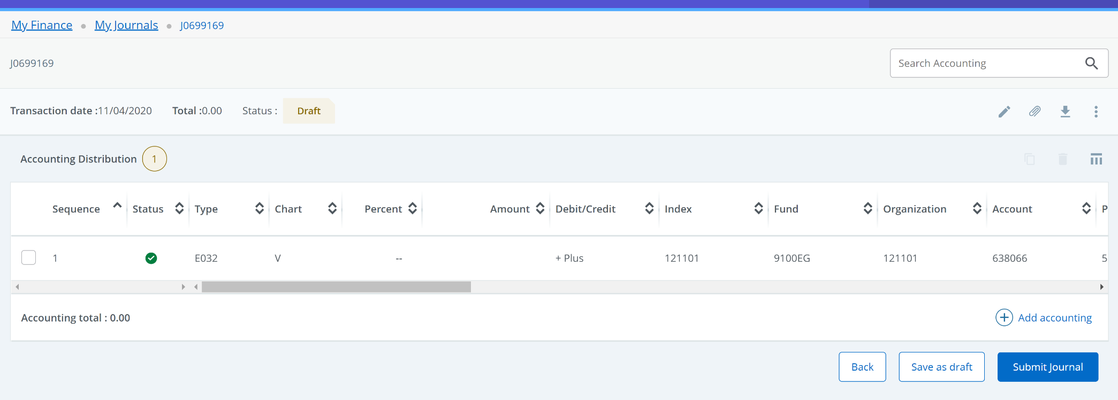

Removing a Travel Encumbrance in Self-Service
After clicking on Submit Journal, a pop-up will appear “Do you want to submit journal Jxxxxxxx?”. Click YES.

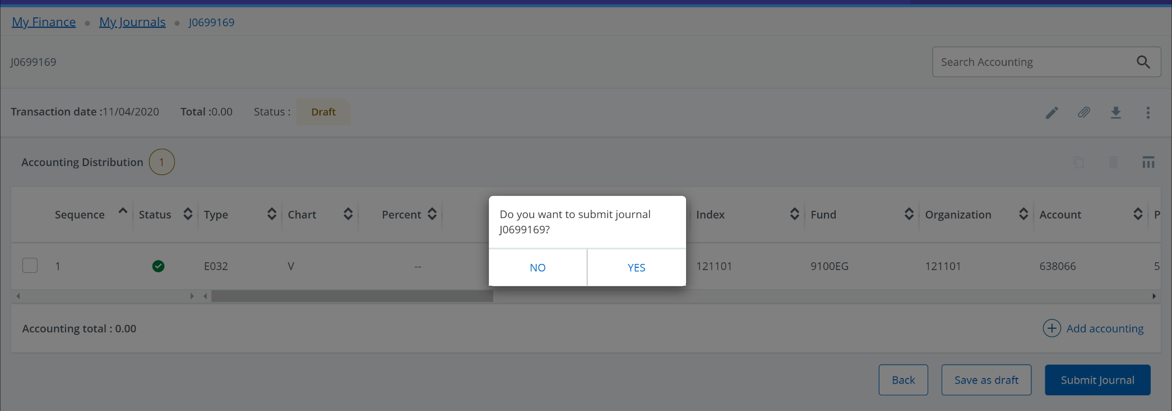

Removing a Travel Encumbrance in Self-Service
After clicking YES, a green message box will appear, “Document Jxxxxxxx completed and forwarded to the approval process. The submitted journal voucher will also show in the Pending Journals section with a status of In Approval.
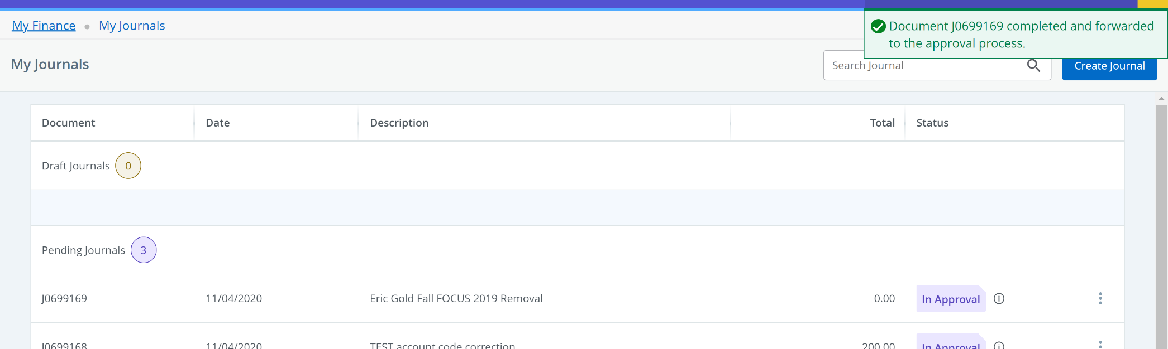

Removing a Travel Encumbrance in Self-Service
After the document has been approved, check Banner form FGIENCD to ensure the Travel Encumbrance balance has been removed.
