Cash Receipt Rule Classes
▪ CCH-Departmental Cash Only Deposit: For cash deposits which are required to be segregated from checks, MasterCard, Visa, American Express or Discover Credit Card deposits. The accounts used are restricted to operating accounts that are not in the labor or internal transfer range. Unique deposit ticket numbers are required to be entered into the Deposit field. Use DP (BoA Deposit) in the Bank field. Budget Period field is blank. For a deposit to an org, use the plus (+) sign in the Debit/Credit field. To
reverse a deposit, use a minus (-) sign in the Debit/Credit field.
▪ CCK-Departmental Check Only Deposit: For check only deposits. The accounts used are restricted to operating accounts that are not in the labor or internal transfer range. Unique deposit ticket numbers are required to be entered into the Deposit field. Use DP (BoA Deposit) in the Bank field. Budget Period field is blank. For a deposit to an org, use the plus (+) sign in the Debit/Credit field. To reverse a deposit, use a minus (-) sign in the Debit/Credit field.

Credit Card Rule Classes:
▪ CDS-Departmental Discover Card Deposit: For Discover Card Deposits.
▪ CMC-Departmental MasterCard/Visa Deposit: For MasterCard and Visa Deposits.
▪ CMX-Departmental American Express Credit Card Deposit: For American Express Credit Card Deposits.

The accounts used are restricted to operating accounts that are not in the labor or internal transfer range.
Use DP (BoA Deposit) in the Bank field. The Deposit field should indicate the cash collection point number (CCP) and the date of the deposit in the following format: “CCPMMDD.” Budget Period field is blank. For a deposit to an org, use the plus (+) sign in the Debit/Credit field. To reverse a deposit, use a minus (-) sign in the Debit/Credit field.
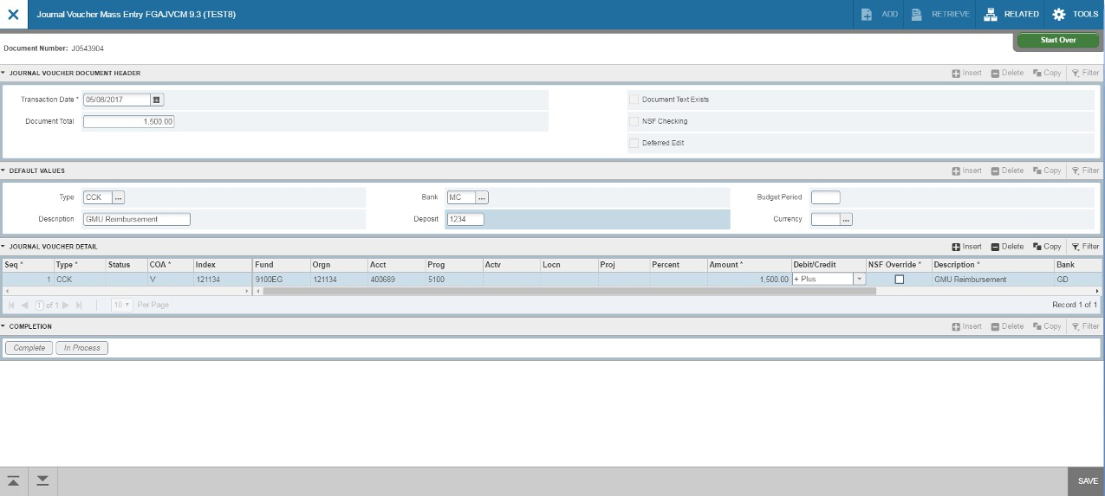
Entering Cash Receipts in Banner Finance
4
3
2
5
6
- Go to Banner form FGAJVCM. Click on Go.
- Transaction Date will auto-fill. Enter the Document Total. This is the total of all the transaction lines.
Departmental cash receipt entries are one line per deposit.
- Type in your Rule Class Type: CCH, CCK, CDS, CMC, CMX. Bank is DP. Type in your description. For the Deposit field, enter the deposit slip number for cash/checks, or the cash collection point number (CCP) and deposit date for credit cards, in the format “CCPMMDD.” Budget Period field is blank.
- Click on Next Section down arrow.
- Tab to Index and enter the Org. Tab to Acct and enter account. Tab to amount and enter amount.
- For cash receipt entries, use the plus (+) and minus (-) indicators in the Debit/Credit field. Tab through the rest of the fields on the line. To move to the next line, press the down arrow key on your keyboard.

Entering Cash Receipts in Banner Finance
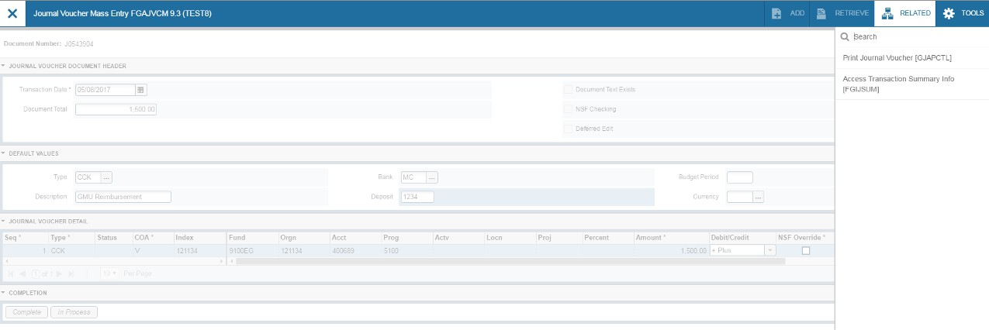
- After completing all lines, press the down arrow key on your keyboard to move to a blank line. Then press the up arrow on your keyboard to remove the line. This ensures that the last line of your entry will populate with Postable in the Status field.
- Select Related>Access Transaction Summary Info from the toolbar.
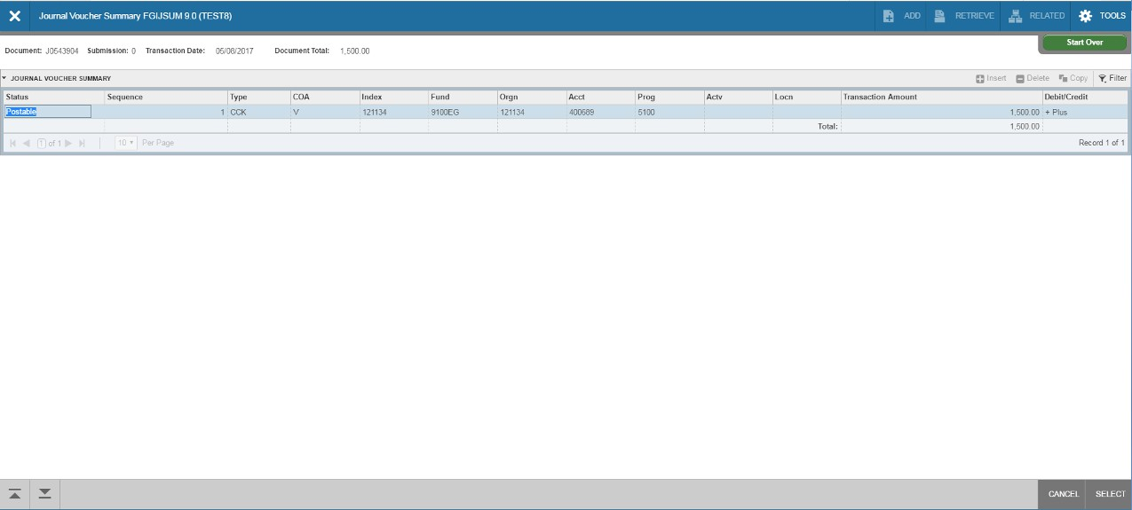
Entering Cash Receipts in Banner Finance
2
1
1
3
- Review your entry on this form. Make sure the document total equals the document total you entered in the key block (first block). Select Related>Access Transaction Summary Info from the toolbar.
- Make sure that all lines of the transaction appear and that each has a status of Postable.
- Click on Cancel at the bottom of the page to exit the form.
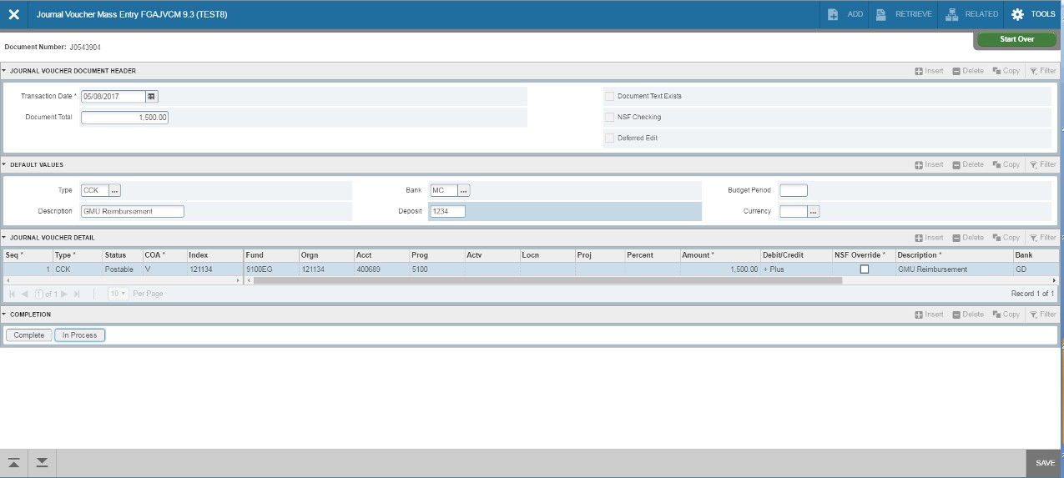
Entering Cash Receipts in Banner Finance
1
2

- At this point, you can click on the Save icon on the toolbar. This is only necessary if you are not
going to submit the journal voucher at this time. If you are ready to submit, click on Next Section down arrow.
- Click on Complete to submit the cash receipt entry

